Hyperliquid Trading Sentiment Analysis
Assessment Report
Candidate: Akansha Walia
Role: Artificial Intelligence (AI)
Date: 17 July 2026

1. Objective
The objective of this analysis is to investigate the relationship between Bitcoin market sentiment, represented by the Fear & Greed Index, and Hyperliquid traders' performance. The study aims to identify trading patterns, evaluate profitability under different market conditions, and generate insights that can support data-driven trading strategies.

2. Dataset Description
Two datasets were used for this analysis:
Historical Trader Data
Contains historical trading records from Hyperliquid, including:
- Account
- Symbol
- Execution Price
- Size
- Side (Buy/Sell)
- Closed PnL
- Leverage
- Timestamp

Bitcoin Fear & Greed Index
Contains daily market sentiment classified as:
- Extreme Fear
- Fear
- Neutral
- Greed
- Extreme Greed
The datasets were merged using the trading date to associate each trade with the corresponding market sentiment.

3. Data Preprocessing
The following preprocessing steps were performed:
- Imported both datasets into Python.
- Converted timestamp columns into datetime format.
- Extracted the date from timestamps.
- Merged both datasets using the common date column.
- Checked for missing values and validated the merged dataset.
- Prepared the dataset for exploratory data analysis.

4. Exploratory Data Analysis
The following analyses were performed:
- Distribution of market sentiment.
- Average Closed PnL across sentiment categories.
- Buy vs Sell trade distribution.
- Top 10 traded cryptocurrencies.
- Distribution of Closed PnL.
- Daily trading activity.
- Top cryptocurrencies based on average Closed PnL.
These visualizations provide an overview of trader behavior and profitability under different market conditions.

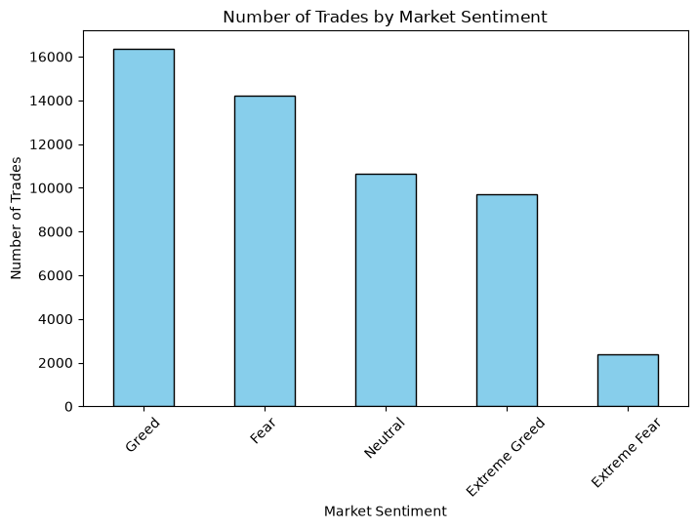

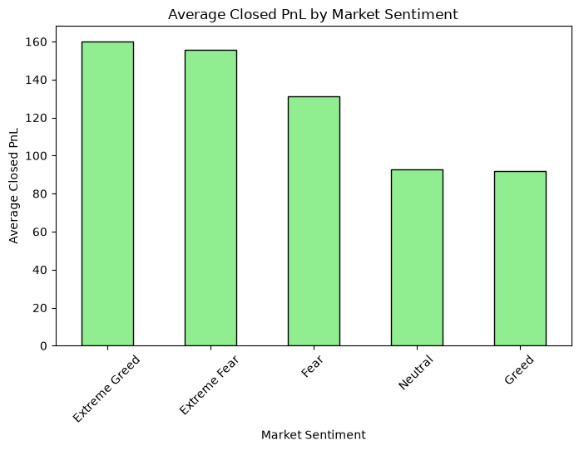

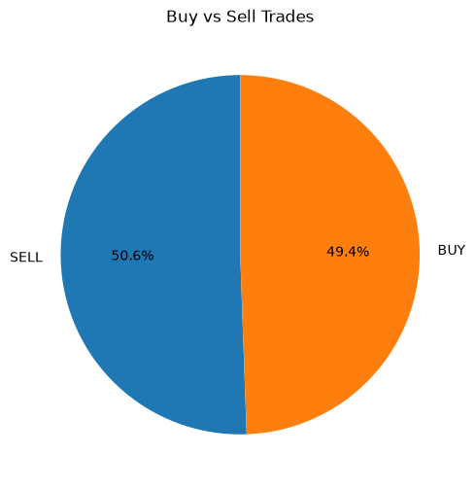
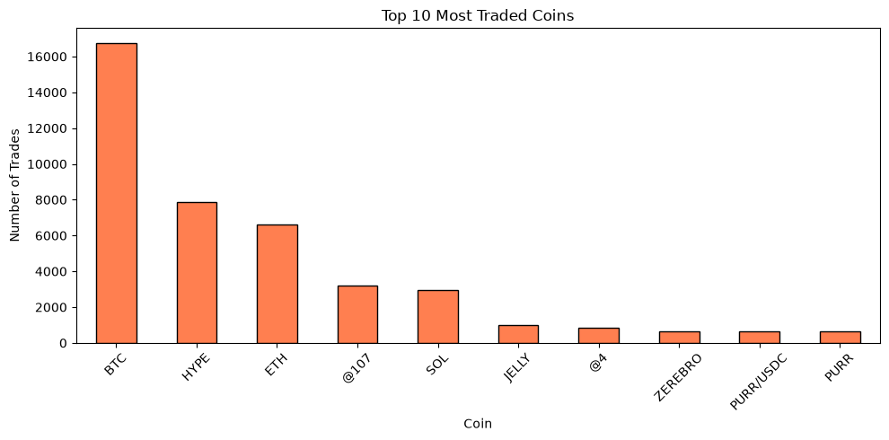

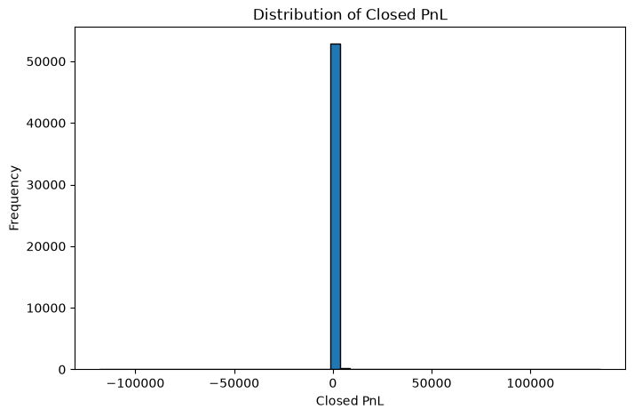

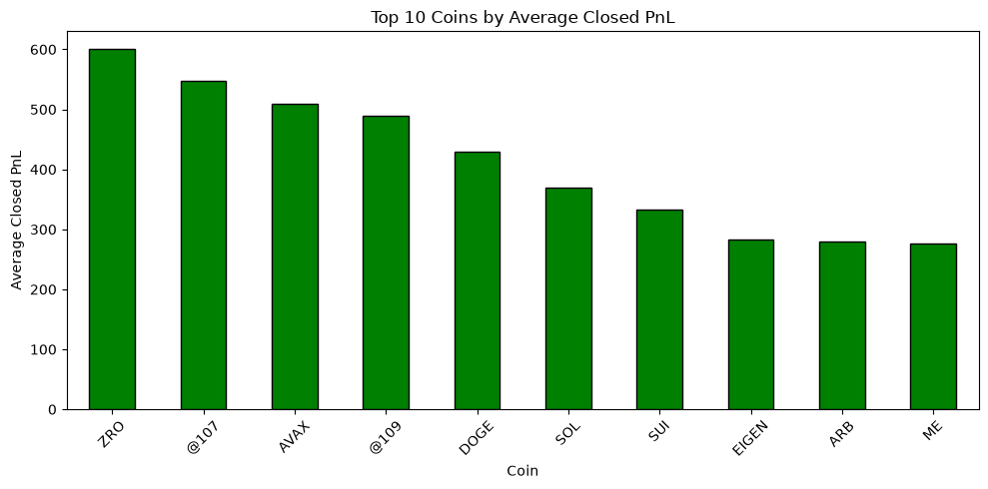

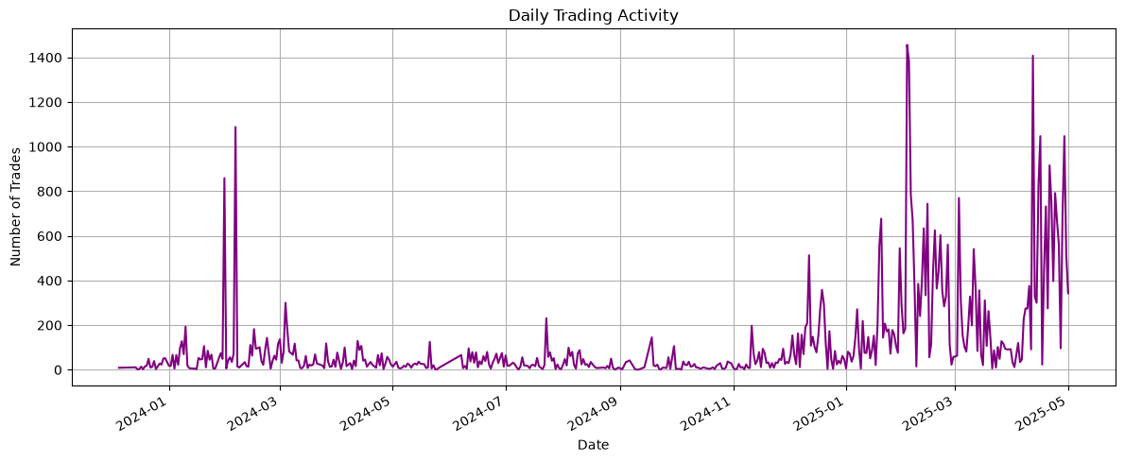

5. Key Findings
The analysis revealed several important insights:
- Trading activity increased significantly during periods of stronger market sentiment.
- Extreme Greed showed the highest average Closed PnL among all sentiment categories.
- Buy and Sell trades were nearly equally distributed, indicating balanced trading behavior.
- BTC and ETH accounted for a large proportion of overall trading activity.
- Daily trading volume experienced noticeable spikes during periods of increased market participation.
- Trader profitability varied considerably depending on market sentiment.

6. Conclusion
This analysis demonstrates that Bitcoin market sentiment has a measurable relationship with Hyperliquid trader performance. Traders generally achieved higher average profits during positive market sentiment, particularly during Extreme Greed periods.
The insights obtained from this analysis can support better trading strategies, risk assessment, and market behavior analysis.

7. Tools & Technologies
- Python
- Pandas
- NumPy
- Matplotlib
- Jupyter Notebook

